**INTERNET OF THINGS**

**TEAM - 08**

**TEAM MEMBERS ROLL NO**

**ASHWANTHRAM A C CB.EN.U4CCE21009**

**GAUTAM R S CB.EN.U4CCE21020**

**DEENADAYALAN S CB.EN.U4CCE21013**

**AKAASHABIMANYU CB.EN.U4CCE21004**

**Amrita School Of Engineering**

**Amrita Vishwa Vidhyapeetham**

**Coimbatore-641112**

**DECEMBER- 2023**

**SMART GLASS FOR VISUALLY CHALLENGED PEOPLE**

**Abstract:**

Introducing Facial Recognition Smart Glasses for the visually challenged—a cutting-edge solution blending advanced facial recognition technology with real-time audio feedback. These glasses empower users by providing instant, discreet verbal descriptions of individuals in their vicinity, fostering independence and social inclusive. With a user-friendly interface, stylish design, and cloud connectivity, this innovation marks a significant leap towards enhancing accessibility and autonomy for the visually impaired.

**Code:**

import picamera

import time

import cv2

import RPi.GPIO as GPIO

import pyttsx3

import numpy as np

def detect_face(frame):

face_cascade = cv2.CascadeClassifier(cv2.data.haarcascades + 'haarcascade_frontalface_default.xml')

gray = cv2.cvtColor(frame, cv2.COLOR_BGR2GRAY)

faces = face_cascade.detectMultiScale(gray, scaleFactor=1.3, minNeighbors=5)

return faces

def measure_distance(trigger_pin, echo_pin):

GPIO.output(trigger_pin, True)

time.sleep(0.00001)

GPIO.output(trigger_pin, False)

pulse_start = time.time()

pulse_end = time.time()

while GPIO.input(echo_pin) == 0:

pulse_start = time.time()

while GPIO.input(echo_pin) == 1:

pulse_end = time.time()

pulse_duration = pulse_end - pulse_start

distance = pulse_duration * 17150

distance = round(distance, 2)

return distance

def speak(text):

engine = pyttsx3.init()

engine.say(text)

engine.runAndWait()

# Set up GPIO

GPIO.setmode(GPIO.BCM)

TRIG = 2

ECHO = 3

GPIO.setup(TRIG, GPIO.OUT)

GPIO.setup(ECHO, GPIO.IN)

GPIO.output(TRIG, GPIO.LOW)

picam = picamera.PiCamera()

try:

picam.rotation = 180

picam.resolution = (640, 480)

picam.framerate = 30

ultrasonic_active = False

with picam as camera:

raw_capture = np.empty((640 * 480 * 3,), dtype=np.uint8)

camera.start_preview(alpha=200)

time.sleep(2)

while True:

camera.capture(raw_capture, format="bgr", use_video_port=True)

frame = raw_capture.reshape((480, 640, 3))

faces = detect_face(frame)

print("detected faces",len(faces))

if len(faces) > 0:

if not ultrasonic_active:

ultrasonic_active = True

print("Ultrasonic sensor activated.")

distance = measure_distance(TRIG, ECHO)

if distance <= 300:

print(f"human detected within {distance} centimeters. Please be cautious(voice command).")

speak(f"human detected within {distance} centimeters. Please be cautious.")

else:

print(f"human detected beyond 3 meters. No voice command.")

else:

if ultrasonic_active:

ultrasonic_active = False

print("Ultrasonic sensor deactivated.")

distance = measure_distance(TRIG, ECHO)

if distance <= 300:

print(f"Obstacle blocking within {distance} centimeters. Please be cautious(voice command).")

speak(f"Obstacle blocking within {distance} centimeters. Please be cautious.")

else:

print(f"No obstacle detected beyond 3 meters.")

except KeyboardInterrupt:

pass

finally:

picam.stop_preview()

picam.close()

GPIO.cleanup()

**Circuit Diagram:**

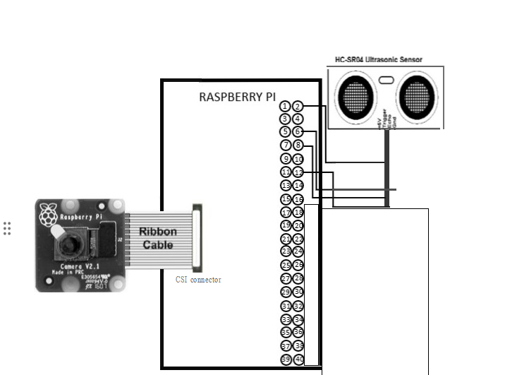

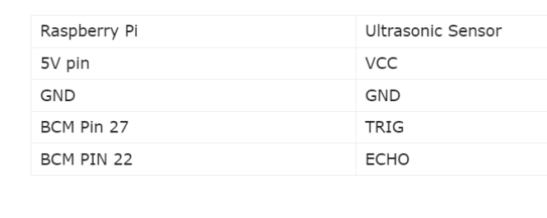

**Working Principle:**

The Facial Recognition Smart Glasses operate by capturing facial features through a discreet camera, utilizing advanced algorithms to identify individuals from a per-loaded database.

Upon recognition, real-time audio feedback delivers concise verbal descriptions to the user.

The device, with a user-friendly interface and stylish design, aims to enhance accessibility and independence for visually challenged individuals by fostering immediate and discreet communication in social interactions. Cloud connectivity ensures continuous updates to the recognition database, improving accuracy over time.

**Output:**

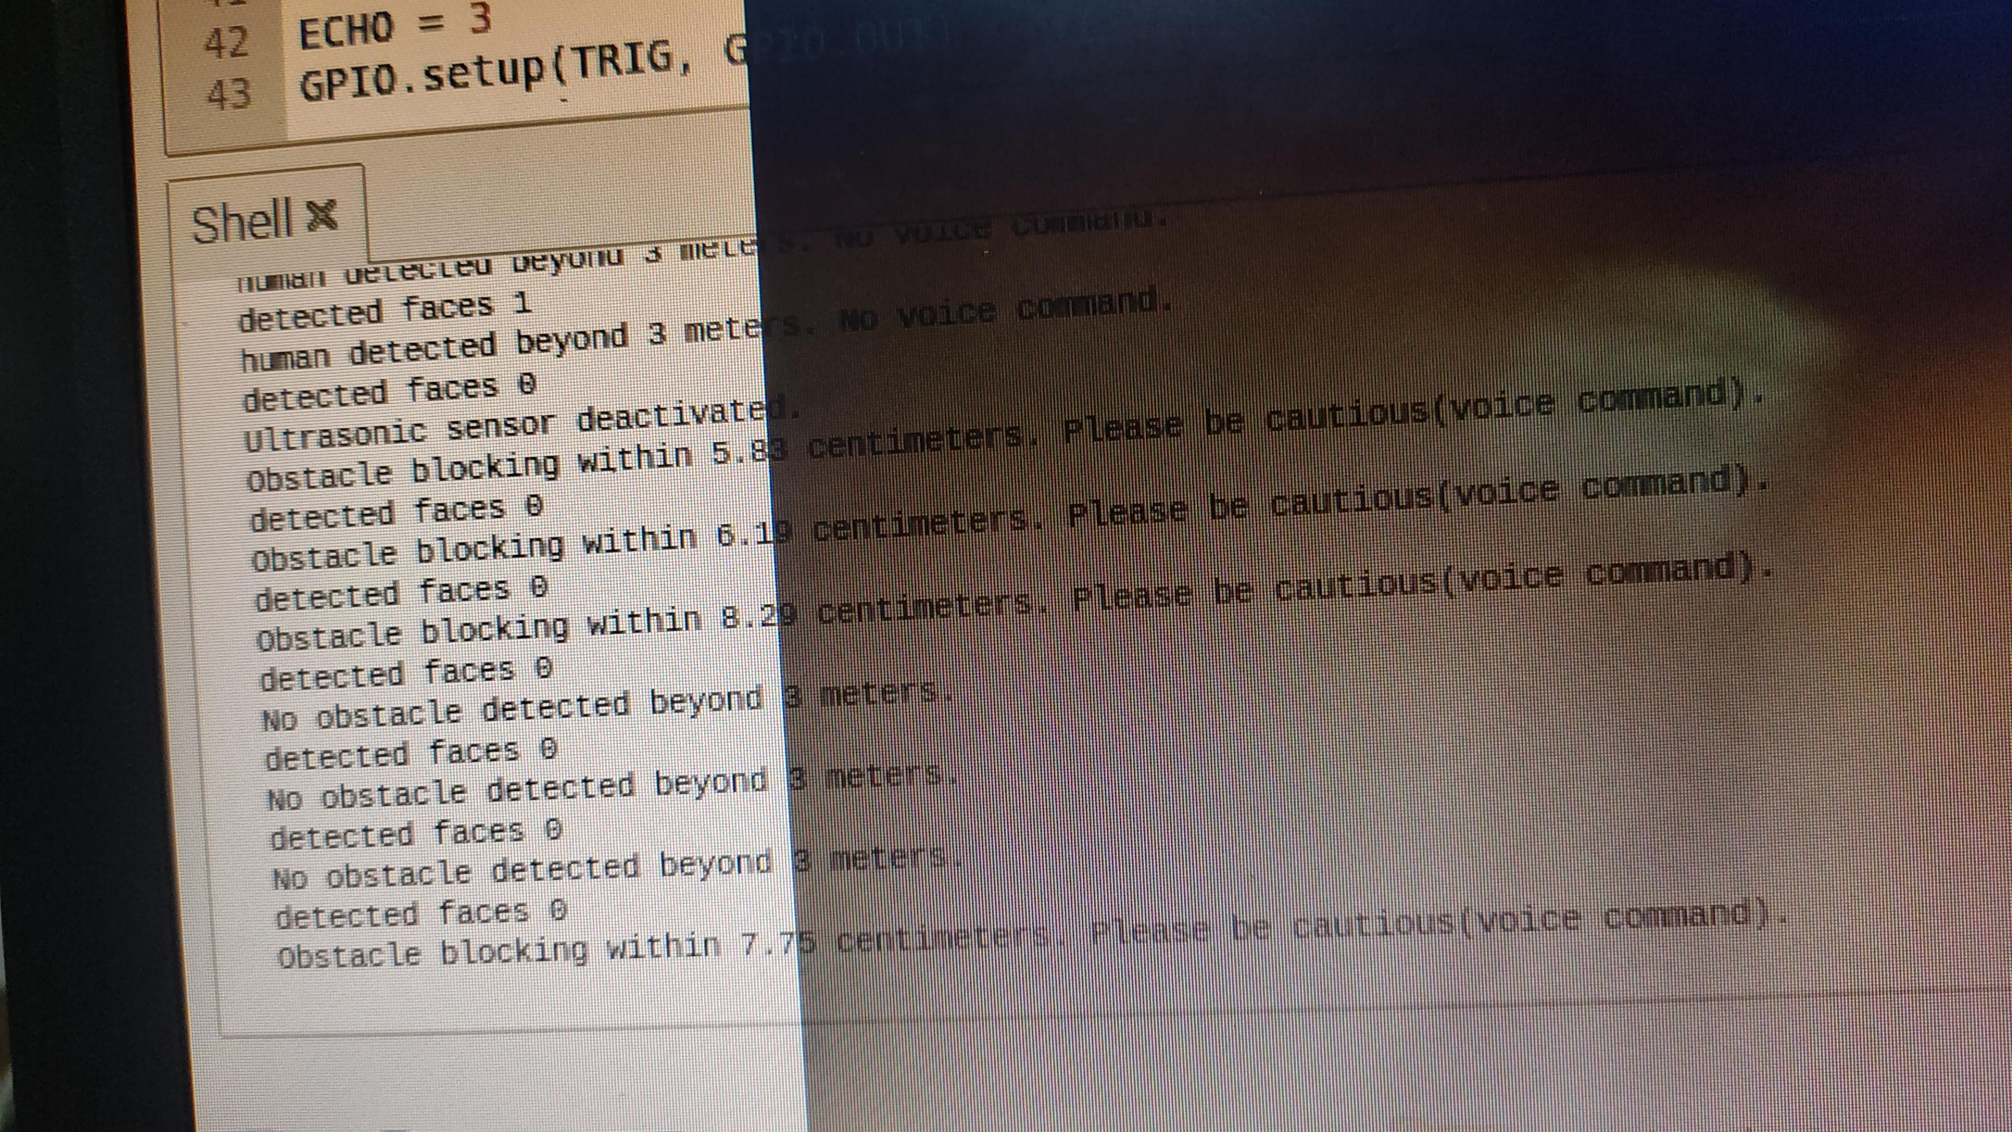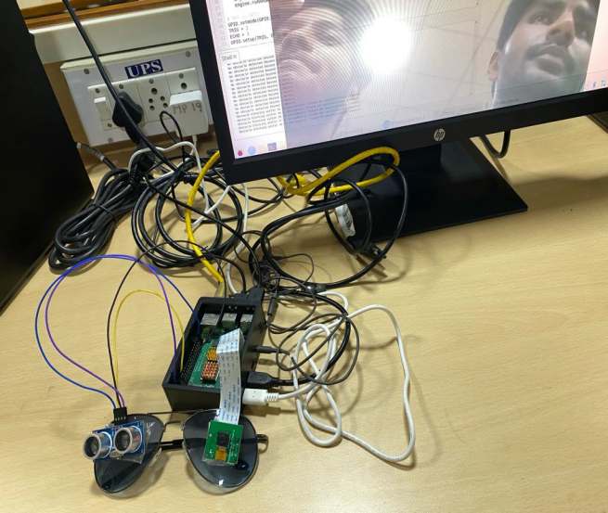

**Result:**